Summary of Existing Work

Summary of Existing Work
Overall, research in automated heart sound analysis has evolved from traditional signal processing techniques to sophisticated deep learning frameworks incorporating attention mechanisms and explainable AI methods. Modern models achieve high classification accuracy and improved interpretability through the integration of attention mechanisms, transformer architectures, and visualization techniques such as Grad-CAM.
However, challenges related to dataset limitations, interpretability, segmentation reliability, and real-world deployment still remain open research problems.
Future research directions include the development of multimodal diagnostic systems that integrate PCG signals with other physiological signals such as electrocardiograms (ECG) to improve diagnostic accuracy and clinical reliability.

Review

Explainable Artificial Intelligence for Heart Sound Analysis

Introduction
Cardiovascular diseases (CVDs) remain one of the leading causes of mortality worldwide, making early detection and accurate diagnosis critically important. Traditionally, clinicians diagnose cardiac abnormalities through auscultation, where heart sounds are interpreted using a stethoscope. These sounds, recorded as phonocardiogram (PCG) signals, contain vital information about the mechanical functioning of the heart, including the S1 and S2 sounds and potential murmurs. However, auscultation is highly dependent on clinical expertise and may lead to inconsistent diagnosis, especially in noisy environments or when subtle abnormalities are present.
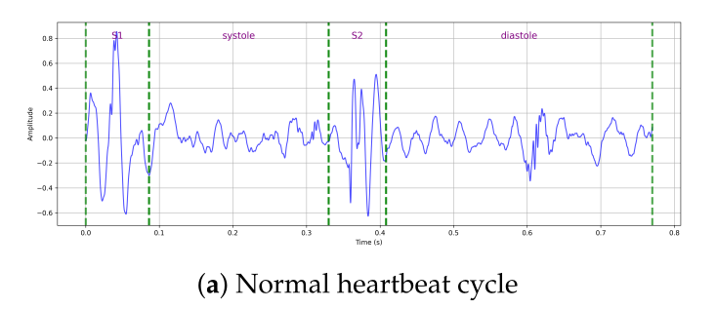
With the advancement of machine learning and deep learning, automated heart sound analysis has gained significant attention. Early approaches relied heavily on handcrafted signal features and classical classifiers such as Support Vector Machines (SVM) or Hidden Markov Models (HMM). While these methods showed promise, their performance depended strongly on manual feature engineering and domain expertise.
Recent years have seen rapid progress in deep learning–based models such as Convolutional Neural Networks (CNNs), Recurrent Neural Networks (RNNs), and attention-centric Transformer architectures for heart sound classification. These models can automatically learn complex representations from PCG signals and achieve high diagnostic accuracy. However, most deep learning models operate as black-box systems, limiting their adoption in healthcare settings where interpretability and trust are essential.
Explainable Artificial Intelligence (XAI) has emerged as a promising solution to this limitation. XAI techniques such as Grad-CAM, SHAP, and LIME provide insights into how models make predictions by highlighting important signal regions or features influencing the classification decision. By integrating explainability with deep learning models, researchers aim to develop diagnostic systems that are not only accurate but also transparent and clinically trustworthy.

1. Datasets and Model Benchmarks
The evolution of high-fidelity cardiac AI is defined by a shift in data curation methodology, moving from small private datasets to large, class distribution, standardized benchmarks, transitioning from automated segmentation to rigorous, expert-guided manual segmentation, recording quality, annotation detail, and clinical coverage. Several publicly available heart sound datasets have been widely used in machine learning research for automated PCG analysis.
Author(s) & Year | Dataset | Classes (Count/Type) | Primary Architecture | Key Performance Metric
Li et al. (2020) | PhysioNet/CinC 2016 | 2 (Binary) | Feature Engineering + CNN (GAP) | Accuracy: 86.8%
Ren et al. (2021) | Heart Sounds Shenzhen (HSS) | 3 (Normal, Mild, Moderate/Severe) | CNN + Global Attention Pooling | UAR: 51.2%
Alrabie & Barnawi (2025) | HeartWave | 4 (Normal, Systolic, Diastolic, Abnormal) | ResNet50 + Multi-head Attention | Accuracy: 97.3%, mIoU: 82.0%
Padhy et al. (2025) | PhysioNet/CinC 2016 | 5 (AS, MR, MS, MVP, Normal) | X-CBNet (CNN-BiLSTM) | Accuracy: 99.15%, AUC: 0.99
Althaph & Challa (2025) | HeartWave, PhysioNet, etc. | Multi-class (up to 9) | Explainable HeartSound Transformer (EHST) | Accuracy: 96.7% (HeartWave)  Accuracy: 90.3% (PhysioNet)
The HeartWave dataset is one of the largest curated PCG datasets containing 1353 recordings and multiple cardiovascular conditions including aortic stenosis, mitral regurgitation, and tricuspid disorders. Each recording is annotated by cardiologists and includes detailed segmentation of heart sound phases such as S1, systole, S2, and diastole.
Other widely used datasets include:
- PhysioNet/CinC 2016 dataset
- CirCor DigiScope dataset
- Pascal heart sound datasets
- Shenzhen heart sound dataset
These datasets differ in recording environments, sampling frequencies, and annotation granularity, which can significantly affect model generalization and evaluation.

2. Methodology: Evolution of Approaches
The methodological development of automated heart sound classification has evolved significantly over the past decade, transitioning from traditional signal-processing techniques to advanced deep learning architectures incorporating attention mechanisms and explainable artificial intelligence. This evolution reflects the need to improve classification accuracy, robustness to noise, and interpretability for clinical adoption.

2.1 Traditional Feature-Based Methods
Early research in automated heart sound analysis relied on handcrafted feature extraction from phonocardiogram (PCG) signals. Common signal processing techniques included wavelet transforms, Fourier transforms, and Mel-Frequency Cepstral Coefficients (MFCC), which capture the spectral characteristics of heart sounds. These extracted features were then classified using conventional machine learning algorithms such as Support Vector Machines (SVM), decision trees, or Hidden Markov Models (HMM).
Although these methods demonstrated initial success in detecting abnormal heart sounds, their performance heavily depended on domain expertise and manual feature engineering. Additionally, handcrafted features were often sensitive to noise and variations in recording environments, limiting their scalability and generalization across datasets.

2.2 Convolutional Neural Networks
With the growth of computational power and the availability of larger datasets, Convolutional Neural Networks (CNNs) emerged as a powerful tool for heart sound classification. Instead of relying on handcrafted features, CNNs automatically learn hierarchical representations from time–frequency representations of PCG signals such as spectrograms and Mel spectrograms.
A notable advancement was introduced by Li et al. (2020), who addressed the overfitting problem common in small medical datasets by replacing traditional fully connected layers with Global Average Pooling (GAP). This approach reduces the number of trainable parameters and improves generalization by summarizing each feature map through global averaging, thereby preventing the network from memorizing training data.
CNN-based architectures significantly improved classification performance and enabled end-to-end learning directly from processed audio representations.
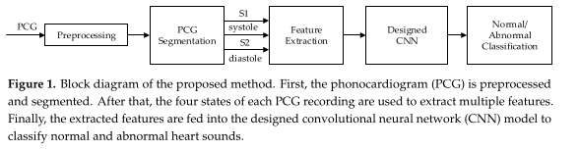

2.3 Hybrid CNN–RNN Architectures
While CNNs effectively capture spatial patterns in spectrogram representations, heart sounds also contain strong temporal dependencies within cardiac cycles. To model these sequential relationships, researchers began integrating recurrent neural networks such as Long Short-Term Memory (LSTM) and Gated Recurrent Unit (GRU) networks with CNN architectures.
In these hybrid models, CNN layers extract spatial features from spectrogram images, while RNN layers capture the temporal dynamics of heartbeats, including the sequential order of S1, systole, S2, and diastole phases.
For instance, Padhy et al. (2025) proposed X-CBNet, a hybrid deep learning framework combining CNN and Bidirectional LSTM layers. The CNN component acts as a feature extractor, while the BiLSTM captures both forward and backward temporal dependencies of heart sound sequences. This architecture achieved state-of-the-art performance in multi-class valvular disease classification tasks.
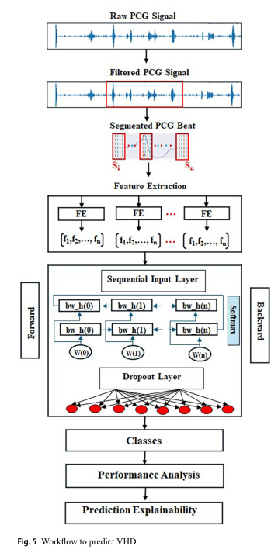

2.4 Attention-Based Models
Although CNN–RNN architectures improved classification accuracy, they often treat all input features equally. In practice, however, only certain parts of a PCG signal—such as systolic or diastolic murmurs—are diagnostically important.
To address this limitation, attention mechanisms were introduced to allow models to dynamically focus on clinically relevant segments of the signal. Attention layers assign different importance weights to different regions of the input, enabling the model to highlight critical acoustic events.
Ren et al. (2021) introduced Global Attention Pooling, which estimates the contribution of each time-frequency feature in a PCG spectrogram. Unlike conventional pooling operations that may discard subtle information, attention pooling selectively emphasizes diagnostically important acoustic patterns, improving disease severity classification.
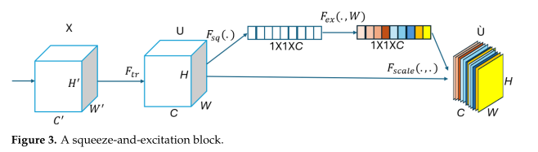
More recently, Alrabie and Barnawi (2025) incorporated Squeeze-and-Excitation (SE) blocks and Multi-Head Attention (MHA) into pretrained CNN architectures to better align model predictions with clinical reasoning. These attention mechanisms guide the model to focus on meaningful cardiac phases such as S1, S2, and murmurs. Additionally, Grad-CAM was employed to visualize the model’s attention regions, allowing researchers to verify whether the network’s predictions correspond to clinically relevant signal segments.

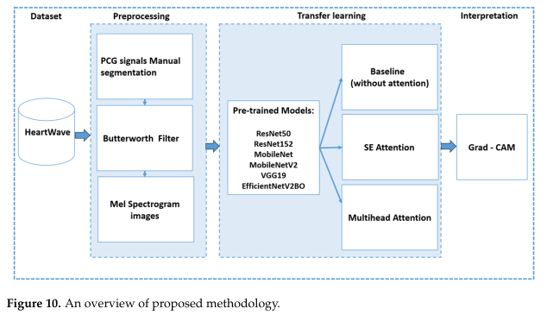

2.5 Transformer-Based Models
Transformer architectures represent the most recent advancement in PCG analysis. Unlike sequential models such as RNNs, Transformers rely on self-attention mechanisms that allow the model to analyze all time steps of a signal simultaneously.
This capability enables Transformers to capture long-range dependencies between different components of the cardiac cycle more effectively than traditional sequential models.
Recent studies have proposed Transformer-based frameworks for heart sound classification. One such model, the Explainable HeartSound Transformer (EHST), employs multi-head self-attention to process entire cardiac cycles in parallel while maintaining interpretability through explainable AI techniques such as Grad-CAM. By integrating deep learning with attention-based interpretability methods, these models achieve high diagnostic accuracy while also providing visual explanations that can be validated by medical experts.
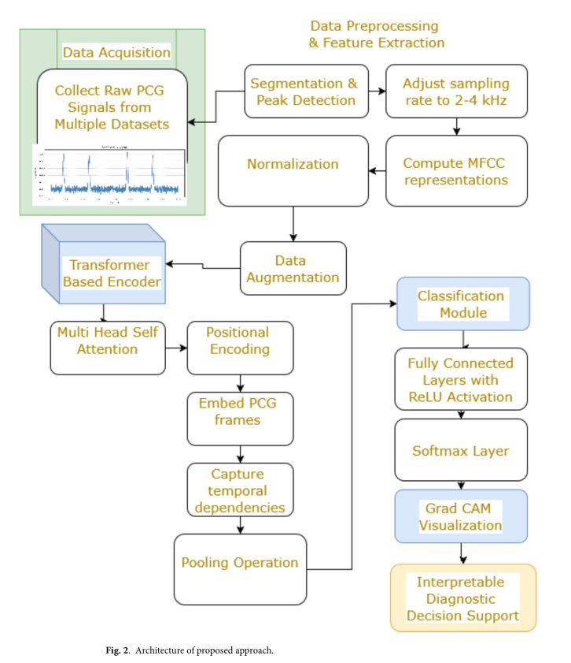

3. Representation of Input
Raw phonocardiogram (PCG) signals are inherently non-stationary and often contaminated by environmental noise, sensor friction, and patient movement. Therefore, effective preprocessing and signal transformation are essential before feeding the data into machine learning models.
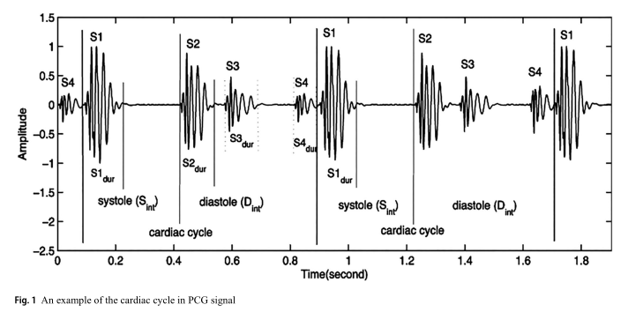
- Preprocessing: Standard practice requires aggressive denoising, often using a 4th-order Butterworth Infinite Impulse Response (IIR) filter (e.g., with a 600 Hz cutoff) to suppress high-frequency noise while preserving fundamental heart sound components, including the S1 and S2 sounds.
- Spectrograms and Log Mel-Spectrograms: The dominant representation in the DL era. Using Short-Time Fourier Transforms (STFT) with specific windowing (e.g., Hann window), audio waves are converted into 2D time-frequency images. Log Mel-spectrograms further transform the frequency scale into the perceptual Mel scale, which aligns more closely with human auditory perception and improves the detection of murmurs and other pathological acoustic patterns.
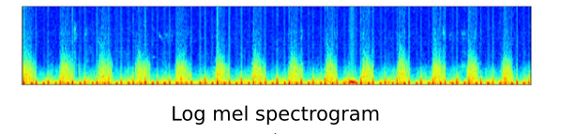
- Mel-Frequency Cepstral Coefficients (MFCCs): MFCC features provide a compact representation of the spectral envelope of audio signals. Frequently used in Transformer architectures, MFCCs provide a highly compressed representation of the spectral envelope, mapping acoustic frequencies to a perceptual scale to distinguish pathological signatures.
These input representations allow deep learning models to learn both temporal and spectral patterns associated with different cardiac conditions, enabling more accurate and robust heart sound classification.

4. Performance Metrics and Interpretability Validation
In clinical AI, high accuracy is a necessary but insufficient condition for reliability. Modern frameworks require a dual-metric approach.
- Standard Predictive Metrics: Models are universally evaluated using Accuracy, Precision, Recall, and AUC-ROC. For highly imbalanced datasets, the Unweighted Average Recall (UAR) and Matthews Correlation Coefficient (MCC) are prioritized to account for minority classes representing rare diseases.
  - Accuracy = (TP + TN) / (TP + TN + FP + FN)
  - Precision = TP / (TP + FP)
  - Recall = TP / (TP + FN)
  - F1 Score = 2 × (Precision × Recall) / (Precision + Recall)
  - True Positive Rate (TPR) = TP / (TP + FN)
  - False Positive Rate (FPR) = FP / (FP + TN)
  - MCC = (TP × TN − FP × FN) / √[(TP + FP)(TP + FN)(TN + FP)(TN + FN)]
  - UAR = (1 / N) × Σ Recall_i
- Interpretability Metrics (mIoU & Fidelity): To quantify how well a model explains itself, researchers utilize the mean Intersection over Union (mIoU). This measures the physical overlap between the model's predicted activation regions (via Grad-CAM heatmaps) and ground-truth bounding boxes drawn by clinical experts. Post-hoc tools like SHAP are also employed to rank feature importance and ensure the model's logic is medically sound.
  - IoU = Area of Overlap / Area of Union
IoU = (Prediction ∩ GroundTruth) / (Prediction ∪ GroundTruth)
The mean IoU across all samples is calculated as:
mIoU = (1 / N) × Σ IoU_i
  - Fidelity = (1 / N) × Σ I(f(xᵢ) = g(xᵢ))

5. Gaps and Challenges
Despite achieving exceptional classification accuracies, several hurdles remain in the path toward seamless clinical integration:
- The "Knowledge Gap" in Visual XAI: While Grad-CAM heatmaps highlight where the model is looking, they do not inherently translate to medical terminology. Highlighting a pixel blob does not explicitly tell a cardiologist if the model detected an "abnormal S2 split" or a "midsystolic click."
- Dataset Limitations: Publicly available heart sound datasets are often limited in size, contain noisy recordings, or lack detailed annotations. These limitations affect model generalization across different clinical environments.
- Segmentation Reliability: Automated segmentation algorithms (like Hidden Markov Models) are highly error-prone in the presence of pathological murmurs. While manual expert segmentation solves this and vastly improves XAI reliability, it is highly resource-intensive and difficult to scale.
- Single-Label vs. Multi-Label Reality: Most current research treats VHD diagnosis as a single-label problem. In clinical reality, patients frequently suffer from multiple concurrent conditions (e.g., regurgitation and stenosis simultaneously), representing a gap that future architectures must address.
- Real-World Noise & Hardware Heterogeneity: Models trained in controlled environments often suffer significant "domain shifts" when transitioning between different digital stethoscopes, each possessing unique sensor sensitivities and noise profiles.

Conclusion
The evolution from global pooling to attention-driven Transformer architectures signifies a paradigm shift in automated cardiac diagnostics. By integrating high-density spectral processing with expert-validated XAI metrics like mIoU and SHAP, the field is approaching a transparent, clinically reliable framework. However, the final bridge to clinical trust will likely require multimodal integration, combining PCG analysis with concurrent Electrocardiogram (ECG) data to provide a comprehensive view of cardiac mechanical and electrical function.

References
[1] S. Alrabie and A. Barnawi, “Are Artificial Intelligence Models Listening Like Cardiologists? Bridging the Gap Between Artificial Intelligence and Clinical Reasoning in Heart-Sound Classification Using Explainable Artificial Intelligence,” Bioengineering, vol. 12, no. 6, 2025.
https://doi.org/10.3390/bioengineering12060558
[2] B. Althaph and N. P. Challa, “Explainable Attention-Based Deep Learning for Classification and Interpretation of Heart Murmurs Using Phonocardiograms,” Scientific Reports, vol. 15, 2025.
https://doi.org/10.1038/s41598-025-21971-x
[3] J. Siva Ramakrishna, S. C. Venkateswarlu, K. N. Kumar, and P. Shreya, “Development of Explainable Machine Intelligence Models for Heart Sound Abnormality Detection,” Indonesian Journal of Electrical Engineering and Computer Science, vol. 36, no. 2, pp. 846–853, 2024.
https://doi.org/10.11591/ijeecs.v36.i2.pp846-853
[4] S. Chakrabarty, P. Bishwas, M. Bandyopadhyay, and J. Sublime, “Can We Trust AI With Our Ears? A Cross-Domain Comparative Analysis of Explainability in Audio Intelligence,” IEEE Access, vol. 13, 2025.
https://doi.org/10.1109/ACCESS.2025.3622161
[5] P. Ren et al., “Heart Sound Classification Using Deep Representation Learning with Attention Mechanism,” IEEE Access, 2021.
https://ieeexplore.ieee.org/document/9334386
[6] P. Li et al., “Classification of Heart Sounds Using Convolutional Neural Networks,” IEEE Access, 2020.
https://ieeexplore.ieee.org/document/9069940
[7] S. Padhy et al., “X-CBNet: An Explainable Deep Learning Framework Based on Spectrograms for Predicting Valvular Disorder Using PCG Signals,” 2025.
https://doi.org/10.1016/j.bspc.2025.105336
[8] PhysioNet/CinC Challenge 2016 Dataset: Heart Sound Classification.
https://physionet.org/content/challenge-2016/1.0.0/
[9] CirCor DigiScope Phonocardiogram Dataset.
https://physionet.org/content/circor-heart-sound/1.0.3/
[10] HeartWave Dataset for Heart Sound Analysis (Referenced in Alrabie & Barnawi, 2025).
https://doi.org/10.3390/bioengineering12060558

